DSA03 – NATURAL LANGUAGE PROCESSING
ASSIGNMENT – 3 (CO3)
ASSIGNMENT TITLE: Design, Parse and Probabilistically Rank English Queries for a University Helpdesk Using Context-Free Grammars, Feature Structures and Earley Parsing.

TASK 1 – DESIGN A CONTEXT-FREE GRAMMAR FOR ENGLISH SYNTAX (5 MARKS)
1.1 INTRODUCTION
A Context-Free Grammar (CFG) is a set of grammatical rules used to describe how words combine to form meaningful sentences. It helps an NLP system identify the structure of English sentences. For the University Helpdesk Assistant, CFG is used to analyse student queries related to examinations, timetables, fees, hostels, libraries and placements.
1.2 FORMAL DEFINITION OF CFG
A Context-Free Grammar is represented as:
G = (N, Σ, R, S)
Where:
- N – Set of non-terminal symbols.
- Σ – Set of terminal symbols (words).
- R – Set of production rules.
- S – Start symbol representing a sentence.
Non-Terminal Symbols:
S, NP, VP, PP, Det, N, V, Adj, Adv, Pron, Aux, WH, CP, AP, Conj.
Terminal Symbols:
Words such as student, teacher, exam, fee, hostel, library, submit, check, attend and register.
Start Symbol: S
1.3 CONTEXT-FREE GRAMMAR RULES
The following rules describe the structure of English sentences.
SENTENCE RULES
- S → NP VP
- S → VP
- S → Aux NP VP
- S → WH VP
- S → WH Aux NP VP
- S → NP Aux VP
- S → S Conj S
- S → CP
NOUN PHRASE RULES
- NP → Det N
- NP → Det Adj N
- NP → Pron
- NP → ProperN
- NP → NP PP
- NP → NP Conj NP
- NP → Det N CP
- NP → Adj N
VERB PHRASE RULES
- VP → V
- VP → V NP
- VP → V NP NP
- VP → V PP
- VP → V CP
- VP → Aux VP
- VP → Adv VP
- VP → VP PP
- VP → V NP PP
- VP → V NP CP
PREPOSITIONAL PHRASE RULES
- PP → P NP
- PP → P Pron
ADJECTIVE PHRASE RULES
- AP → Adj
- AP → Adv Adj
- NP → Det AP N
COORDINATION RULES
- NP → NP Conj NP
- VP → VP Conj VP
- AP → AP Conj AP
CLAUSE RULES
- CP → Comp S
- CP → WH S
- CP → WH Aux NP VP
IMPERATIVE RULES
- IMP → V NP
- IMP → V NP PP
RELATIVE CLAUSE RULES
- CP → Rel S
These 40 rules form the basic grammar for the university helpdesk system.
1.4 LEXICON
The lexicon contains the words used by the grammar.
Part of Speech | Words
Nouns | student, teacher, exam, timetable, fee, hostel, library, book, room, notice, result, assignment, course, placement, form, portal, receipt, department, seminar, application
Verbs | check, submit, show, book, attend, apply, send, tell, register, pay, announce, display, open, close, provide
Determiners | the, a, an, this, that, these, those
Pronouns | I, you, we, they, he, she, me, us, them
Prepositions | in, on, at, near, for, with, from, to
Adjectives | late, new, available, pending, important, postponed
Adverbs | quickly, recently, currently
Auxiliary Verbs | is, are, do, does, can, will, should
WH Words | what, when, where, which, who, how
Conjunctions | and, or, but
Complementizers | that, whether, if
Proper Nouns | Chennai, Saveetha, Monday
The lexicon contains more than 60 words covering different university helpdesk activities.
1.5 CONSTITUENCY, HEAD AND PHRASAL CATEGORY
Constituency: A group of words that functions as a single unit in a sentence.
Head: The main word that determines the function of a phrase.
Phrasal Category: The grammatical category of a phrase, such as NP, VP or PP.
Example 1: The student submits the form.
- Noun Phrase: The student
- Verb Phrase: submits the form
- Head of NP: student
- Head of VP: submits
Example 2: The student studies in the library.
- NP: The student
- VP: studies in the library
- PP: in the library
Example 3: Check the examination timetable.
- VP: Check the examination timetable.
- NP: the examination timetable
- Head of NP: timetable
1.6 CONSTITUENCY TESTS
Three common constituency tests are:
- Substitution Test: Replace a phrase with a pronoun. Example: "The student submits the form" becomes "He submits the form."
- Movement Test: Move a phrase to another position. Example: "In the library, the student studies."
- Coordination Test: Join two similar phrases using a conjunction. Example: "The student and the teacher attend the meeting."
1.7 CONTEXT-FREE PROPERTY
The grammar is context-free because every production rule replaces one non-terminal with a sequence of symbols independently of its surrounding context. However, English agreement and long-distance dependencies can be difficult to represent using a basic CFG. Feature structures can help handle these limitations.
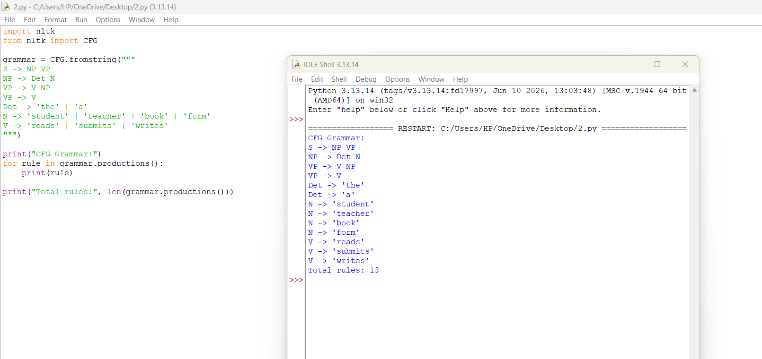

TASK 2 – CONTEXT-FREE RULES, DERIVATIONS AND PARSE TREES
2.1 INTRODUCTION
A derivation shows how a sentence is generated using grammar rules. A parse tree represents the grammatical structure of that sentence.
There are two main derivation methods:
- Leftmost Derivation: The leftmost non-terminal is expanded first.
- Rightmost Derivation: The rightmost non-terminal is expanded first.
2.2 SAMPLE SENTENCES
Five sentences selected from the university helpdesk queries:
- The student submits the form.
- The teacher checks the timetable.
- Students attend the examination.
- The librarian issues a book.
- The student checks the result.
2.4 PARSE TREE
Bracketed Notation:
(S (NP (Det The) (N student)) (VP (V submits) (NP (Det the) (N form))))
Tree Diagram:
S
/ \
NP VP
/ \ / \
Det N V NP
| | | / \
The student submits Det N
| |
the form
Tree Measurements:
- Height: 4 edges.
- Number of nodes: 11.
- Rule applications: 4.
2.5 AMBIGUOUS SENTENCES
An ambiguous sentence has more than one possible grammatical interpretation.
Example 1: Show the students with the late fee notice.
- Parse 1: The students have the late fee notice.
- Parse 2: Show the students who are associated with the notice.
The PP "with the late fee notice" can attach to different parts of the sentence.
Example 2: Book the room near the library for the seminar.
- Parse 1: The room near the library should be booked.
- Parse 2: The room should be booked for the seminar, with a different attachment of the PP.
2.6 DERIVATION AND PARSE TREE RELATIONSHIP
A derivation describes the sequence of grammar-rule applications, whereas a parse tree shows the final hierarchical structure. Different derivation orders can produce the same parse tree. Therefore, multiple derivations do not always indicate different meanings.
2.7 STRING MEMBERSHIP TEST
To check whether a sentence belongs to L(G):
- Start with the start symbol S.
- Apply suitable grammar rules.
- Match the generated terminals with the input words.
- Check whether all words are consumed.
- If a complete derivation is possible, the sentence belongs to L(G).
The method may become expensive for long and ambiguous sentences.
TASK 3 – SENTENCE-LEVEL CONSTRUCTIONS (4 MARKS)
3.1 INTRODUCTION
English sentences are classified into different constructions based on their purpose and structure.
The helpdesk system must understand declarative, imperative, yes/no and WH-question sentences.
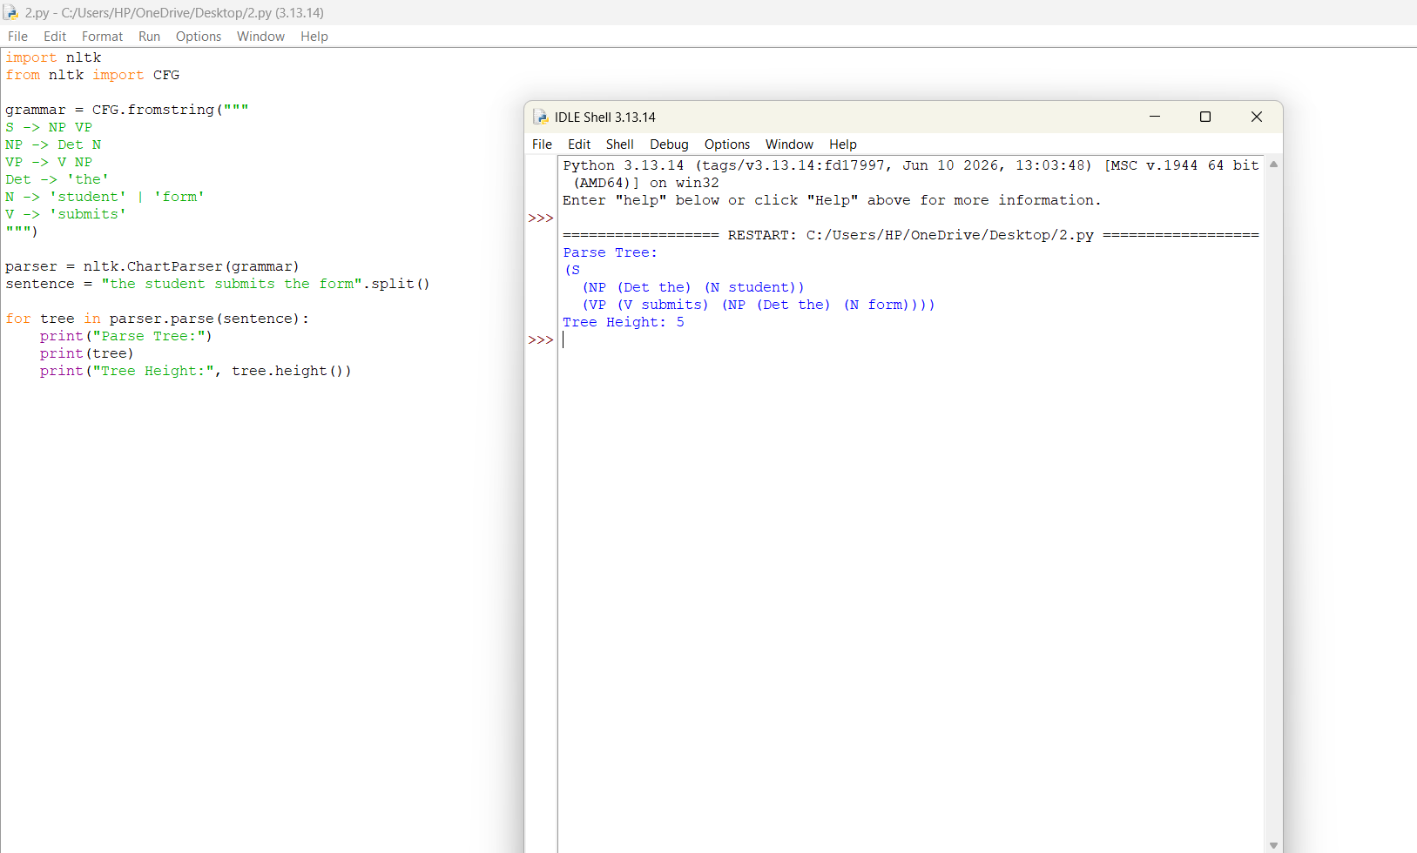
3.2 FOUR MAIN SENTENCE TYPES
1. DECLARATIVE SENTENCES
Declarative sentences provide information.
Rule:
S → NP VP
Example: The student checks the timetable.
Parse:
S
/ \
NP VP
| |
The student checks the timetable
2. IMPERATIVE SENTENCES
Imperative sentences express commands or instructions. The subject "you" is generally understood.
Rule:
IMP → V NP
Example: Submit the application form.
3. YES/NO QUESTIONS
These questions expect a yes or no answer.
Rule:
S → Aux NP VP
Example: Can the student attend the examination?
The auxiliary verb "Can" appears before the subject.
4. WH-QUESTIONS
WH-questions request specific information.
Rules:
S → WH Aux NP VP
S → WH VP
Examples:
- When will the examination start?
- What is the examination fee?
- Who submitted the application?
3.3 AUXILIARY INVERSION
Auxiliary inversion means placing an auxiliary verb before the subject in questions.
Example:
Declarative: The student can attend the exam.
Question: Can the student attend the exam?
3.4 WH-MOVEMENT
WH-movement moves a question word to the beginning of a sentence.
Example:
The examination starts when.
When does the examination start?
The WH-word "when" moves to the beginning.
3.5 SUBORDINATE AND RELATIVE CLAUSES
A subordinate clause depends on another clause.
Example: The student knows that the examination is postponed.
A relative clause provides additional information about a noun.
Example: The exams that were postponed will be conducted tomorrow.
Rule:
CP → Rel S
3.6 COORDINATION
Coordination joins two or more similar grammatical structures using conjunctions.
Example: The student checks the fees and hostel charges.
Rule:
NP → NP Conj NP
3.7 EFFECT ON GRAMMAR
Adding questions, subordinate clauses and relative clauses increases the number of grammar rules.
It also increases ambiguity because a sentence may contain several possible structures. A more advanced parser is required to handle these constructions efficiently.
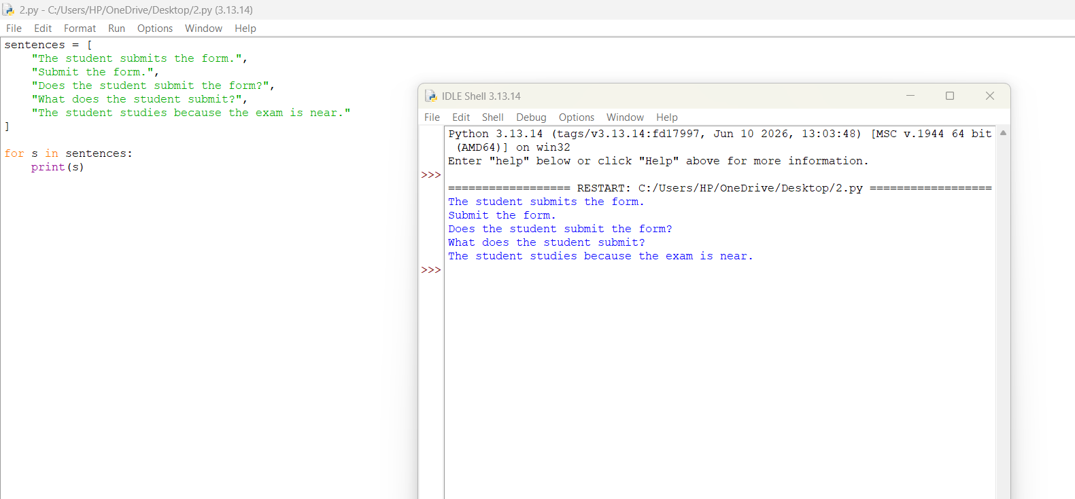
TASK 4 – AGREEMENT
4.1 INTRODUCTION
Agreement is the grammatical relationship between words in a sentence.
The helpdesk grammar must handle subject–verb agreement, determiner–noun agreement and pronoun case.
4.2 TYPES OF AGREEMENT
1. Subject–Verb Agreement
The subject and verb must agree in number and person.
Correct: The student submits the form.
Incorrect: The students submits the form.
2. Determiner–Noun Agreement
Determiners must match the number of nouns.
Correct: These students.
Incorrect: These student.
3. Pronoun Case
Pronouns must be used in the correct grammatical position.
Correct: She helps me.
Incorrect: Me helps she.
4.3 AGREEMENT USING MULTIPLIED NON-TERMINALS
Agreement can be handled by creating separate grammatical categories.
Rules:
S → NP-SG VP-SG
S → NP-PL VP-PL
NP-SG → Det-SG N-SG
NP-PL → Det-PL N-PL
VP-SG → V-SG NP
VP-PL → V-PL NP
This method prevents incorrect combinations.
4.4 RULE EXPLOSION
If a grammar represents person, number, case and gender separately, the number of possible feature combinations increases.
Assume:
- Person: 3 values.
- Number: 2 values.
- Case: 3 values.
- Gender: 3 values.
Total combinations:
3 × 2 × 3 × 3 = 54 combinations.
This increases grammar complexity and makes maintenance difficult.
4.5 FEATURE-BASED ALTERNATIVE
Feature-based grammar represents grammatical information using attributes instead of creating many separate categories.
Example:
NP: [NUM = singular]
VP: [NUM = singular]
The parser accepts the sentence only when the features match.
4.6 AGREEMENT TESTING
Sentence | Original CFG | Agreement-Aware CFG
The student submits the form. | Accept | Accept
The students submit the form. | Accept | Accept
She checks the timetable. | Accept | Accept
They attend the exam. | Accept | Accept
The students submits the form. | Accept | Reject
These student attends class. | Accept | Reject
This students submit forms. | Accept | Reject
Me checks the timetable. | Accept | Reject
He submit the form. | Accept | Reject
They attends the examination. | Accept | Reject
The teacher check the result. | Accept | Reject
These book is available. | Accept | Reject
The original CFG does not explicitly enforce agreement. The agreement-aware grammar rejects incorrect combinations.
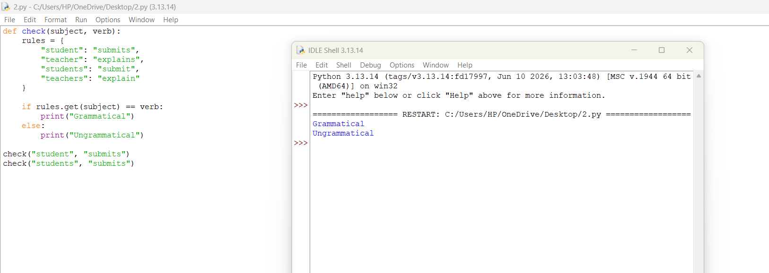
TASK 5 – SUBCATEGORIZATION (4 MARKS)
5.1 INTRODUCTION
Subcategorization describes the types and number of complements that a verb requires to form a grammatically complete sentence.
Different verbs require different complements.
5.2 FIVE TYPES OF SUBCATEGORIZATION FRAMES
Frame | Structure | Example
Intransitive | V | The portal crashed.
Transitive | V + NP | Submit the form.
Ditransitive | V + NP + NP | Send me the receipt.
Sentential | V + CP | Tell me that the fee is paid.
PP Complement | V + PP | Apply for a hostel room.
5.3 GRAMMAR RULES
VP → V-INTR
VP → V-TRANS NP
VP → V-DITRANS NP NP
VP → V-COMP CP
VP → V-PP PP
These rules ensure that verbs receive their required complements.
5.4 SUBCATEGORIZATION LEXICON
Verb | Subcategorization
Crash | Intransitive
Submit | Transitive
Send | Ditransitive
Tell | Sentential
Apply | PP complement
Attend | Transitive
Register | PP complement / Intransitive
Show | Transitive / Ditransitive
5.5 COMPLEMENTS AND ADJUNCTS
Complement: A phrase required or selected by a verb.
Example: Submit the form.
Here, "the form" is the complement.
Adjunct: An optional phrase that provides additional information.
Example: Submit the form tomorrow.
Here, "tomorrow" is an adjunct because it gives additional time information.
5.6 ACCEPTANCE AND REJECTION
Sentence | Result | Reason
The portal crashed. | Accept | Intransitive verb
Submit the form. | Accept | Transitive verb
Send me the receipt. | Accept | Ditransitive verb
Tell me that the fee is paid. | Accept | Sentential complement
Apply for a hostel room. | Accept | PP complement
Submit. | Reject | Missing required object
The portal crashed the form. | Reject | Incorrect complement
Send the receipt me. | Reject | Incorrect argument order
5.7 MULTIPLE VERB FRAMES
Some verbs can take more than one type of complement.
Example: "Show"
- Show the result.
- Show me the result.
Multiple frames increase grammatical flexibility but can also increase ambiguity and parsing complexity.
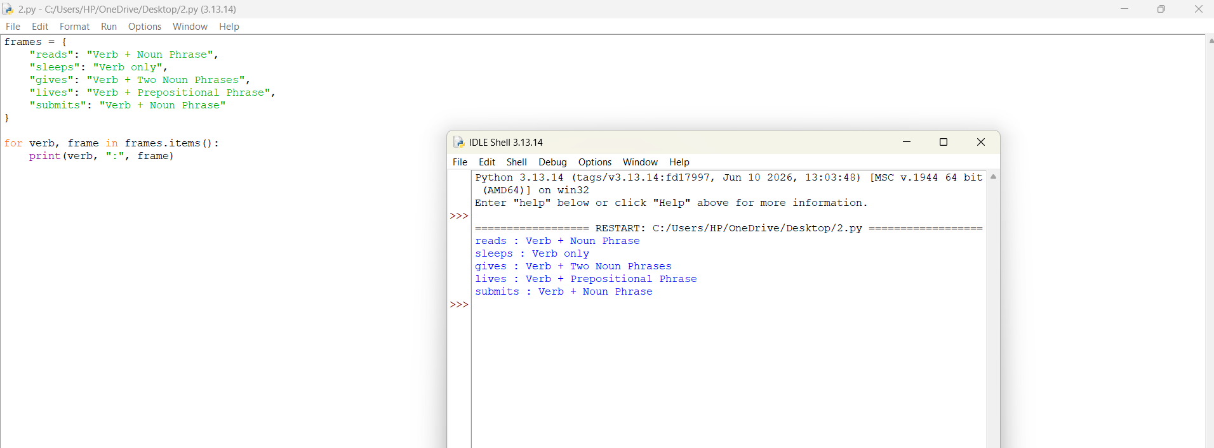
TASK 6 – TOP-DOWN PARSING
6.1 INTRODUCTION
Top-down parsing is a parsing technique that begins with the start symbol S and attempts to generate the input sentence using grammar rules.
It follows a goal-driven approach.
6.2 WORKING PROCEDURE
- Start with the symbol S.
- Select a suitable grammar rule.
- Expand the non-terminal symbols.
- Match the generated words with the input.
- Backtrack when a rule does not match.
- Continue until the complete sentence is parsed.
6.3 PSEUDOCODE
START
Initialize stack with S

While stack is not empty:
Read the top symbol

If it is a terminal:
Match it with input word
If matched:
Move to next word
Else:
Backtrack

Else:
Expand using grammar rules

If all words are matched:
Accept sentence
Else:
Reject sentence
END
6.4 PARSING EXAMPLE
Sentence: The student submits the form.
Step | Current Action
1 | Start with S
2 | Expand S → NP VP
3 | Expand NP → Det N
4 | Match The student
5 | Expand VP → V NP
6 | Match submits
7 | Expand NP → Det N
8 | Match the form
9 | Accept sentence
6.5 AMBIGUOUS SENTENCE
Sentence: Show the students with the late fee notice.
The parser may explore different PP attachment possibilities.
It tries one grammar rule first. If the selected structure fails, it backtracks and explores another possibility.
6.6 LEFT RECURSION
A grammar contains left recursion when a non-terminal refers to itself as the first symbol on its right-hand side.
Example:
NP → NP PP
This can cause a recursive-descent parser to continue expanding NP without consuming any input.
6.7 LEFT-RECURSION ELIMINATION
Original rule:
NP → NP PP | Det N
Modified rules:
NP → Det N NP'
NP' → PP NP' | ε
The modified grammar removes direct left recursion.
6.8 ADVANTAGES AND LIMITATIONS
Advantages:
- Easy to understand.
- Simple to implement.
- Starts from the sentence structure.
- Useful for small grammars.
Limitations:
- Problems with left recursion.
- Requires backtracking.
- May repeat the same computations.
- Ambiguous sentences increase parsing time.
6.9 TIME COMPLEXITY
For a general CFG, naive top-down parsing with backtracking can take exponential time in the worst case.
Repeated PP attachments increase the number of possible structures. Dynamic programming techniques can reduce this repeated work.
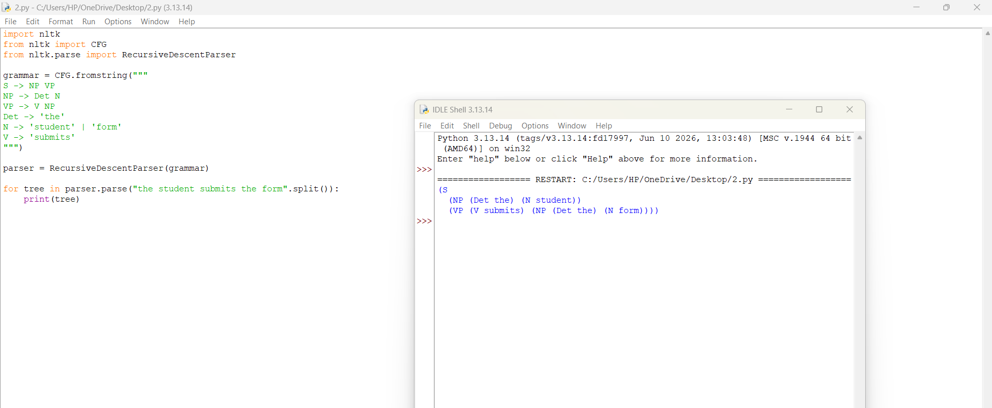

TASK 7 – EARLEY PARSING (5 MARKS)
7.1 INTRODUCTION
Earley Parsing is a dynamic programming algorithm used to analyse sentences according to a context-free grammar.
It handles left recursion and ambiguous sentences efficiently by storing intermediate parsing results in a chart.
7.2 EARLEY STATE
An Earley state contains:
- A grammatical production rule.
- A dot showing the parsing position.
- The starting position of the rule.
Example:
S → NP • VP [0]
The dot indicates that NP has been processed and VP is expected next.
7.3 THREE MAIN OPERATIONS
1. PREDICTOR
Predictor adds possible grammar rules when the next expected symbol is a non-terminal.
2. SCANNER
Scanner matches an expected terminal with the next input word.
3. COMPLETER
Completer combines completed grammatical structures with the rules that were waiting for them.
7.4 SAMPLE SENTENCE
"The student submits the form."
Input:
The | student | submits | the | form
The sentence contains six words if punctuation is counted as a separate token.
7.5 EARLEY CHART
The chart contains sets of states:
S[0], S[1], S[2], S[3], S[4], S[5].
Example state progression:
Chart | Main Operation | Description
S[0] | Predictor | Predicts S → NP VP
S[1] | Scanner | Matches The
S[2] | Completer | Completes NP
S[3] | Scanner | Matches submits
S[4] | Scanner | Matches the
S[5] | Scanner and Completer | Completes the final NP and VP
The completed start state is:
[S → NP VP •, 0]
This indicates that the complete sentence has been recognised.
7.6 AMBIGUOUS PARSING
For the sentence:
"Book the room near the library."
The PP "near the library" can be attached to the noun phrase or the verb phrase.
The Earley parser stores the possible structures using shared chart states and back-pointers.
This avoids repeating the same intermediate calculations.
7.7 HANDLING LEFT RECURSION
Earley parsing can handle left-recursive grammar rules such as:
NP → NP PP
It avoids infinite recursive expansion by storing states in chart sets and preventing duplicate states from being added repeatedly.
7.8 COMPLEXITY
For a general CFG:
- Worst-case time complexity: O(n³).
- Space complexity: O(n²) for the chart.
Where n represents the number of input words.
7.9 COMPARISON WITH TOP-DOWN PARSING
Feature | Top-Down Parser | Earley Parser
Starting point | Start symbol | Chart-based
Left recursion | Problematic | Supported
Ambiguity | Backtracking | Chart states
Repeated work | Higher | Reduced
Memory | Lower | Higher
Complexity | Exponential worst case | O(n³) worst case
Earley parsing is more suitable for the university helpdesk because it supports recursive structures and ambiguity.
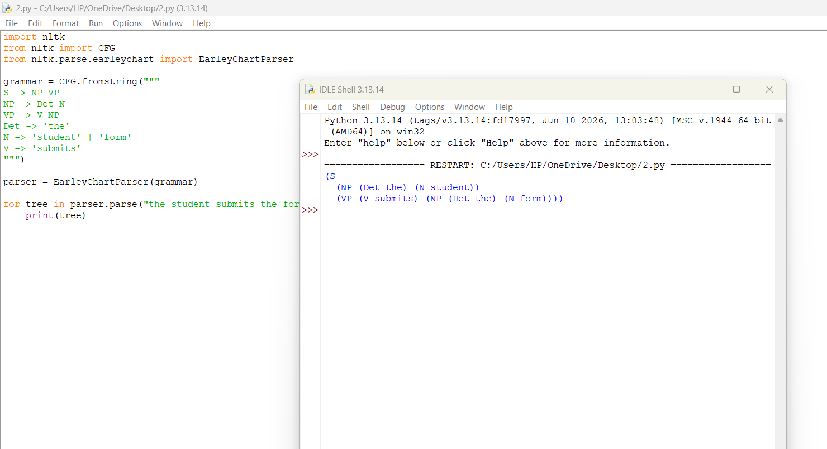
TASK 8 – FEATURE STRUCTURES AND UNIFICATION
8.1 INTRODUCTION
Feature structures represent grammatical information using attribute-value pairs.
They help a parser handle agreement and subcategorization without creating a large number of separate grammar rules.
8.2 FEATURE STRUCTURE
A feature structure contains attributes such as:
- NUM – Number.
- PER – Person.
- CASE – Grammatical case.
- GENDER – Gender.
- SUBCAT – Subcategorization.
Example:
NP:
[NUM: Singular, CASE: Nominative, PER: Third]
8.3 FEATURE-BASED LEXICAL ENTRIES
Word | NUM | PER | CASE | SUBCAT
Student | Singular | Third | Nominative | —
Students | Plural | Third | Nominative | —
She | Singular | Third | Nominative | —
Me | Singular | First | Accusative | —
Submit | — | — | — | NP
Send | — | — | — | NP + NP
8.4 FEATURE PATHS
A feature path identifies a particular attribute inside a feature structure.
Example:
NP.NUM
It refers to the number feature of the noun phrase.
8.5 REENTRANCY
Reentrancy means sharing the same feature value between two grammatical structures.
Example:
The number feature of the subject NP is shared with the VP agreement feature.
8.6 UNIFICATION
Unification is the process of combining two feature structures when their values are compatible.
Example 1:
A = [NUM: Singular]
B = [NUM: Singular]
Result = [NUM: Singular]
Unification succeeds.
Example 2:
A = [PER: Third]
B = [PER: Third]
Result = [PER: Third]
Unification succeeds.
Example 3:
A = [NUM: Singular]
B = [NUM: Plural]
Result = Failure.
The two values are incompatible.
8.7 FEATURE-BASED GRAMMAR RULES
- S → NP VP
- NP → Det N
- VP → V NP
- NP → Pron
- VP → V PP
- VP → V CP
Feature constraints:
- The subject and verb must agree in number and person.
- The determiner and noun must agree in number.
- Subject pronouns must use nominative case.
- Object pronouns must use accusative case.
- Verb complements must satisfy the SUBCAT requirement.
8.8 COMPLETE FEATURE STRUCTURE
Sentence: The student submits the form.
Subject NP:
[NUM: Singular, PER: Third]
Verb:
[NUM: Singular, PER: Third]
Object NP:
[NUM: Singular, CASE: Accusative]
All required features are compatible. Therefore, the sentence is accepted.
8.9 ADVANTAGES
- Reduces grammar rule duplication.
- Handles subject–verb agreement.
- Handles pronoun case.
- Supports subcategorization.
- Improves grammar maintenance.
8.10 EARLEY PARSING WITH UNIFICATION
Feature structures can be integrated into Earley parsing.
During the COMPLETER operation, the parser checks whether the feature values of completed constituents are compatible with the expected grammatical structure.
If unification succeeds, parsing continues. Otherwise, that particular parse is rejected.
Feature checking adds computational cost because feature structures must be compared and combined
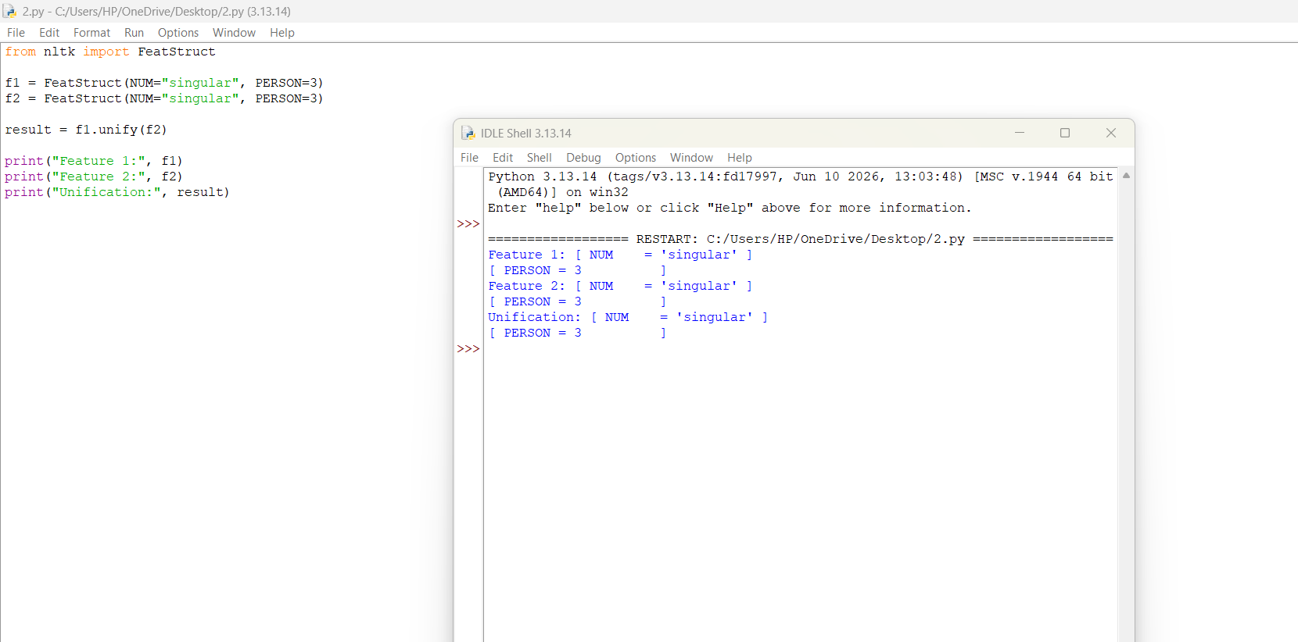.
TASK 9 – PROBABILISTIC CONTEXT-FREE GRAMMARS (5 MARKS)
9.1 INTRODUCTION
A Probabilistic Context-Free Grammar (PCFG) is an extension of CFG in which every grammar rule is assigned a probability.
It helps select the most likely parse tree when a sentence has multiple possible interpretations.
9.2 PCFG DEFINITION
A PCFG assigns a probability to each production rule.
Example:
S → NP VP [1.0]
NP → Det N [0.6]
NP → Pron [0.4]
For every non-terminal, the probabilities of its alternative production rules must add up to 1.
9.3 RULE PROBABILITY CALCULATION
Maximum Likelihood Estimation (MLE) is used to calculate rule probabilities.
Formula:
P(A → β) = Count(A → β) / Count(A)
Where:
- Count(A → β) = Number of times a rule occurs.
- Count(A) = Total number of occurrences of the left-hand-side non-terminal.
9.4 SAMPLE TREEBANK
A mini treebank containing 20 manually annotated sentences is considered for estimating grammar probabilities.
Example rule counts:
Grammar Rule | Count | Probability
S → NP VP | 20 | 1.00
NP → Det N | 12 | 0.60
NP → Pron | 8 | 0.40
VP → V NP | 10 | 0.50
VP → V | 4 | 0.20
VP → V PP | 4 | 0.20
VP → Aux VP | 2 | 0.10
Det → The | 12 | 0.60
Det → A | 8 | 0.40
For each left-hand-side category, the probabilities sum to 1.
These are illustrative hand-designed counts for the proposed 20-sentence treebank.
9.5 HANDLING UNSEEN RULES
An unseen rule receives zero probability under basic maximum likelihood estimation.
Smoothing techniques can be used to avoid zero probabilities.
Add-one smoothing is one simple method that adds a small count to unseen events. In practical PCFG systems, more suitable smoothing methods may also be used.
9.6 PROBABILITY OF PARSE TREES
Consider the sentence:
"Book the room near the library."
Two possible interpretations are:
Parse 1 – PP Attachment to NP
The room near the library should be booked.
Parse 2 – PP Attachment to VP
Book the room near the library.
Assume the following illustrative probabilities:
Rule | Probability
S → VP | 0.30
VP → V NP | 0.50
NP → Det N | 0.60
NP → NP PP | 0.20
PP → P NP | 0.80
VP → VP PP | 0.20
The probability of a complete tree is calculated by multiplying the probabilities of all rules used in that tree.
Parse 1:
P(T1) = 0.30 × 0.50 × 0.60 × 0.20 × 0.80 × 0.60
P(T1) = 0.00864
Parse 2:
P(T2) = 0.30 × 0.50 × 0.60 × 0.20 × 0.80 × 0.20
P(T2) = 0.00288
Therefore:
P(T1) > P(T2)
The first parse is preferred under these illustrative probabilities.
Sentence probability:
P(Sentence) = P(T1) + P(T2)
= 0.00864 + 0.00288
= 0.01152
9.7 PROBABILISTIC CKY ALGORITHM
CKY is a bottom-up parsing algorithm used with a grammar converted into Chomsky Normal Form (CNF).
The Viterbi version selects the highest-probability parse.
Main Steps:
- Convert the grammar into CNF.
- Divide the sentence into individual words.
- Initialize the diagonal cells using lexical rules.
- Combine smaller constituents into larger constituents.
- Calculate the probability of each possible combination.
- Store the highest-probability result.
- Select the best parse tree from the final cell.
9.8 CNF CONVERSION
In Chomsky Normal Form, productions generally follow:
A → BC
A → a
Where A, B and C are non-terminals and a is a terminal.
Example:
Original:
VP → V NP PP
Converted:
VP → V X
X → NP PP
The intermediate symbol X helps convert the grammar into binary form.
9.9 LIMITATIONS OF PCFG
- It assumes that rule probabilities depend mainly on the parent category.
- It does not fully capture the relationship between distant words.
- It may prefer shorter or more common structures.
- It has limited lexical sensitivity.
- It requires annotated training data.
Despite these limitations, PCFG improves ambiguity resolution by ranking possible parse trees.
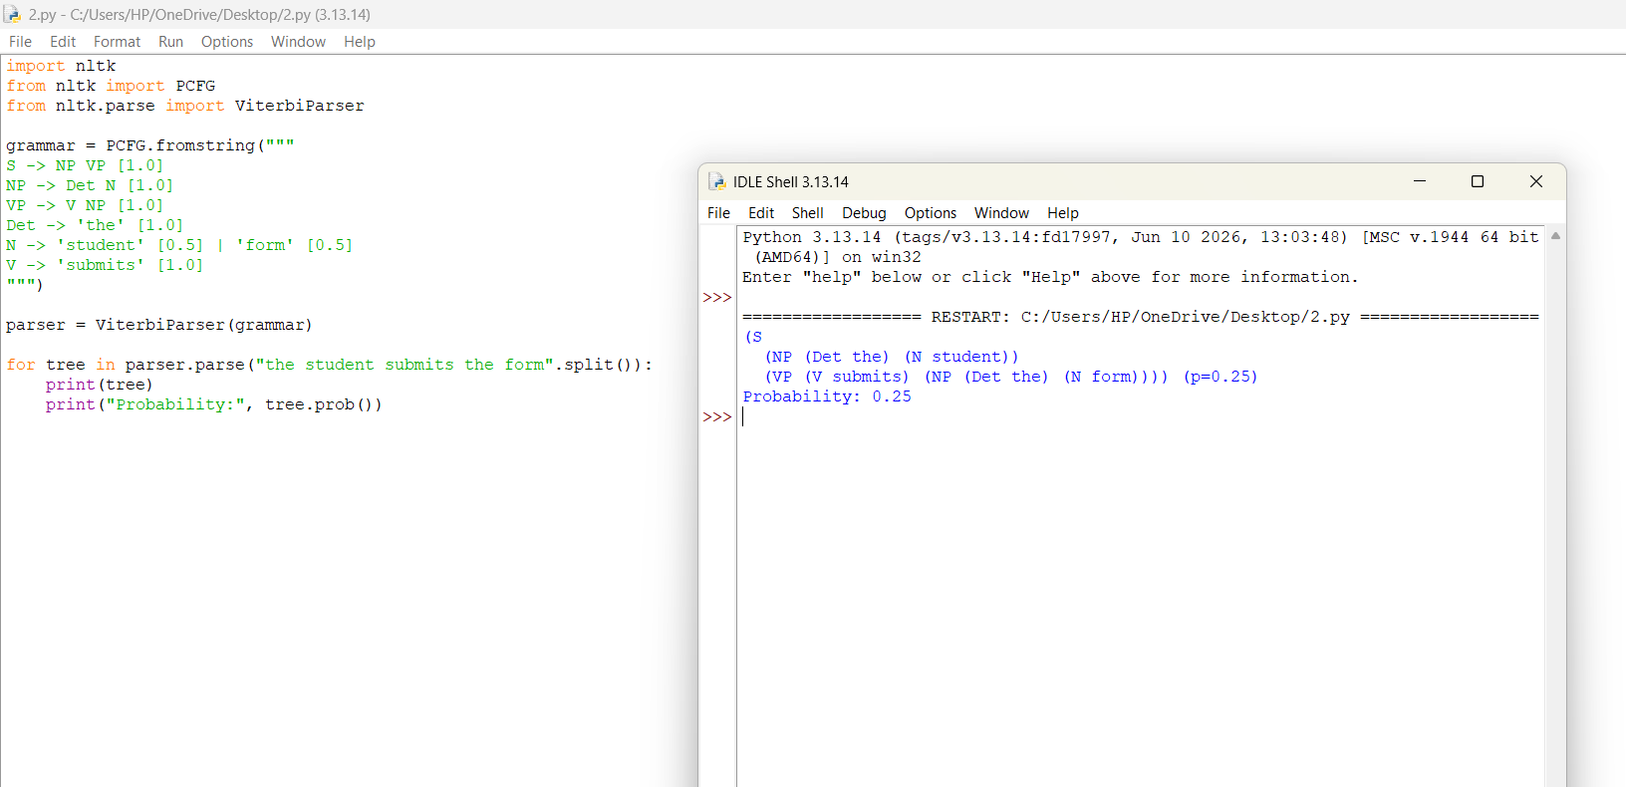
TASK 10 – IMPLEMENT AND TEST THE PARSERS (3 MARKS)
10.1 INTRODUCTION
The implementation stage checks whether the designed grammar and parsing algorithms work correctly on university helpdesk queries.
Python and the NLTK library can be used to implement the grammar and parsers.
10.2 TOOLS AND TECHNOLOGIES
Tool | Purpose
Python | Main programming language
NLTK | Grammar and parsing
Matplotlib | Graph generation
VS Code | Code development
Pandas | Organising test results
10.3 PARSERS TO BE IMPLEMENTED
1. TOP-DOWN PARSER
Starts from the start symbol S and expands grammar rules to match the input sentence.
2. EARLEY PARSER
Uses chart-based dynamic programming to identify sentence structures and handle ambiguity.
3. PCFG PARSER
Calculates the probability of different parse trees and selects the most likely structure.
4. FEATURE CHECKING
Checks subject–verb agreement, determiner–noun agreement, pronoun case and verb subcategorization.
10.4 TEST SENTENCE COLLECTION
The following 30 sentences are used for testing.
DECLARATIVE SENTENCES
- The student submits the form.
- The teacher checks the timetable.
- Students attend the examination.
- The librarian issues a book.
- The portal displays the result.
- The hostel provides accommodation.
- The placement officer announces the schedule.
- The student pays the fee.
IMPERATIVE SENTENCES
- Submit the application form.
- Check the examination timetable.
- Register for the course.
- Visit the library.
YES/NO QUESTIONS
- Can the student attend the exam?
- Is the library open?
- Does the teacher check the result?
- Will the placement drive start tomorrow?
WH-QUESTIONS
- When will the examination start?
- Where is the hostel?
- What is the semester fee?
- Who submitted the application?
AMBIGUOUS SENTENCES
- Show the students with the late fee notice.
- Book the room near the library for the seminar.
- The teacher saw the student with the book.
- Check the timetable in the department office.
- The student discussed the result with the teacher.
ADDITIONAL TEST SENTENCES
- The exams that were postponed will be conducted tomorrow.
- The student and teacher attend the meeting.
- The portal crashed yesterday.
- The students submits the form.
- These student attends the examination.
10.5 TESTING PARAMETERS
The following parameters are used to evaluate the parsers:
- Sentence acceptance or rejection.
- Number of parse trees.
- Number of chart states.
- Number of parsing steps.
- Execution time.
- Agreement checking accuracy.
10.6 COMPARISON OF PARSERS
Parameter | Top-Down | Earley | PCFG
Grammar support | CFG | CFG | Probabilistic CFG
Left recursion | Difficult | Supported | Depends on parser
Ambiguity | Backtracking | Multiple parses | Best parse ranking
Agreement | Additional checks | Feature extension | Feature extension
Main purpose | Sentence generation | Chart parsing | Parse selection
10.7 PERFORMANCE GRAPH
A graph can be prepared using:
- X-axis: Sentence Length.
- Y-axis: Number of Parsing States.
The graph compares the growth in parsing states for top-down and Earley parsing.
Earley parsing avoids repeated intermediate calculations by storing states in a chart.
10.8 TESTING RESULT
The grammar is expected to accept grammatical sentences and reject sentences that violate the implemented agreement and subcategorization constraints.
Ambiguous sentences may produce multiple parse trees, while the PCFG ranks them according to probability.
Actual execution time, parse counts and chart-state measurements should be recorded from the Python implementation rather than treated as theoretical values.
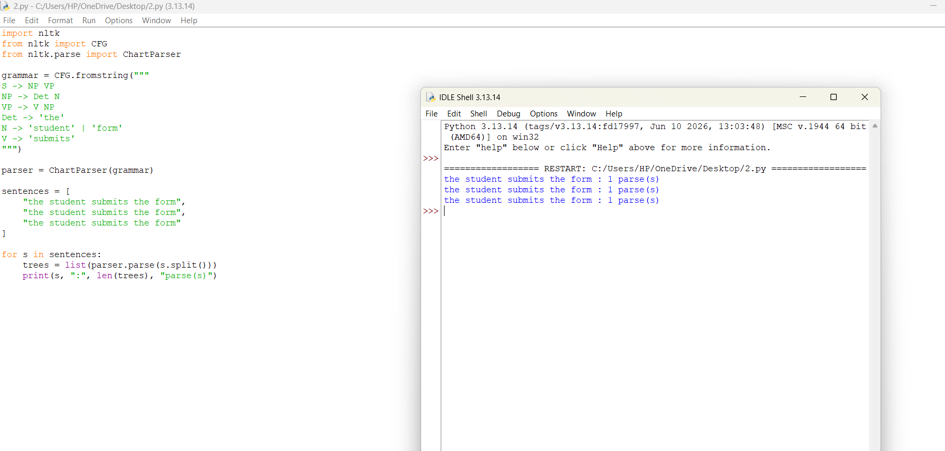
TASK 11 – COMPARE, RECOMMEND AND DEFEND THE PARSING DESIGN (2 MARKS)
11.1 COMPARISON
Feature | Top-Down | Earley | PCFG
Parsing approach | Goal-driven | Dynamic programming | Probability-based
Ambiguity handling | Limited | Good | Ranks alternatives
Left recursion | Problem | Handles it | Depends on underlying parser
Accuracy | Grammar-dependent | Grammar-dependent | Probability-dependent
Complexity | Can be exponential | O(n³) | Depends on parsing algorithm
Maintenance | Simple initially | Moderate | Requires probability updates
11.2 RECOMMENDED DESIGN
The recommended system is:
FEATURE-BASED CFG + EARLEY PARSER + PCFG RANKING
The feature-based grammar handles agreement and subcategorization. The Earley parser generates possible grammatical structures, and the PCFG selects the most probable parse.
11.3 JUSTIFICATION
- CFG provides a structured representation of English sentences.
- Feature structures reduce unnecessary grammar rules.
- Earley parsing supports recursive and ambiguous constructions.
- PCFG helps select the most likely interpretation.
- Python provides a practical environment for implementation and testing.
11.4 EFFORT AND COST DISCUSSION
The main manual efforts include:
- Writing grammar rules and preparing the lexicon.
- Creating and annotating the sample sentences.
- Implementing and testing the parsers.
- Estimating probabilities from the mini treebank.
- Evaluating parsing accuracy and execution time.
The proposed design requires initial manual effort, but it provides a reusable grammar-based foundation for the university helpdesk.
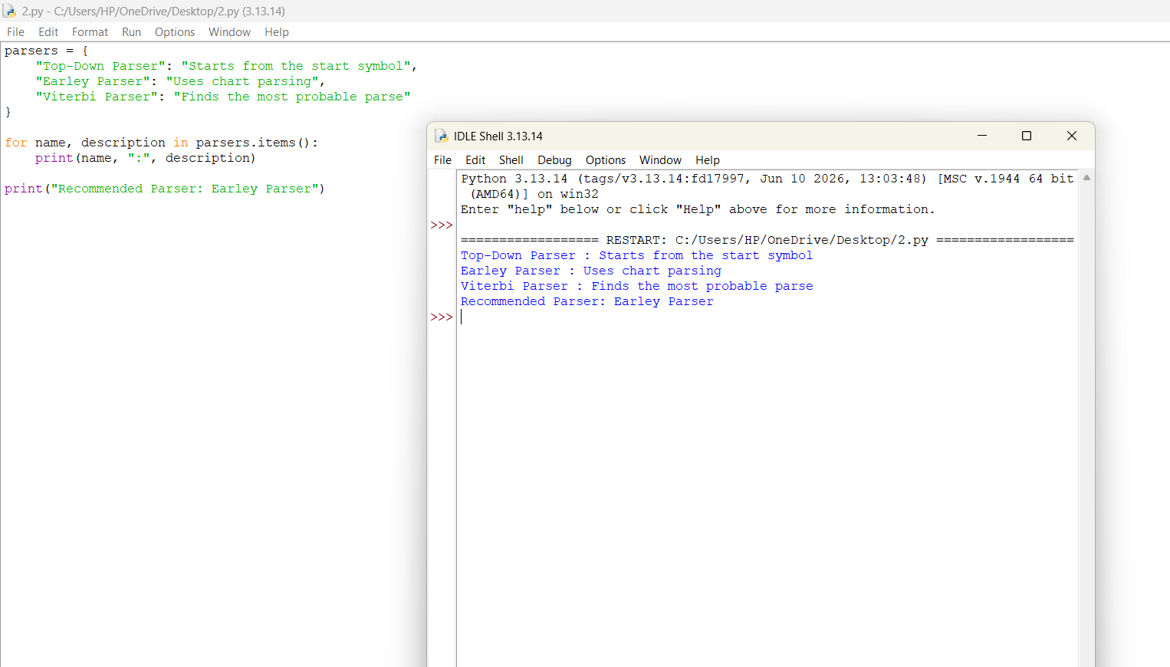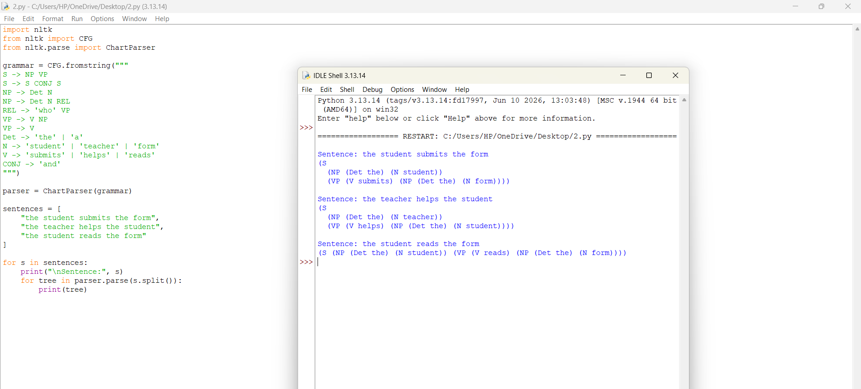
TASK 12 – DAY-4 DESIGN CHALLENGE: RE-EVALUATE AND ADAPT THE DESIGN (8 MARKS)
A. IMPACT ANALYSIS (2 MARKS)
12.1 CHANGES IN REQUIREMENTS
The original system was designed for simple and controlled English sentences. The new requirement introduces conversational messages, multiple clauses, embedded questions, relative clauses and incomplete sentences.
Example:
"Hi, can you tell me when the exams that were postponed will be held, and also whether the hostel fee is due?"
This sentence contains multiple grammatical structures.
12.2 NEW CONSTRUCTIONS
The revised system must handle:
- Embedded questions.
- Multiple coordinated clauses.
- Relative clauses.
- Missing punctuation.
- Conversational expressions.
- Incomplete sentences and fragments.
- Unfamiliar words and constructions.
12.3 AFFECTED ASSUMPTIONS
Original Assumption | New Requirement
Controlled vocabulary | Larger vocabulary
Simple sentences | Multi-clause sentences
Correct grammar | Noisy and incomplete input
Limited ambiguity | Higher ambiguity
Small grammar | Extended grammar
12.4 EFFECT ON PARSING
Longer sentences contain more words and grammatical relationships.
They may produce more possible parse trees and increase the number of chart states.
The original grammar may fail when it encounters an embedded construction that is not covered by its rules.

B. EVALUATION OF THE ORIGINAL DESIGN
12.5 TESTING NEW MESSAGES
MESSAGE 1:
"Can you tell me when the exams will be held?"
Problem: The original grammar may not fully support embedded WH-questions.
MESSAGE 2:
"The exams that were postponed will be conducted tomorrow."
Problem: The relative clause requires additional grammatical rules.
MESSAGE 3:
"Hi, I need the hostel fee details and also want to know when the library opens."
Problem: The message contains conversational expressions and coordinated clauses.
12.6 ORIGINAL PARSER PERFORMANCE
Parser | Expected Behaviour
Top-Down | May fail or require repeated backtracking
Earley | Handles supported CFG structures but rejects uncovered constructions
PCFG | Ranks available parses but cannot create missing grammar rules
12.7 AMBIGUITY AND CHART SIZE
As sentence length increases, the number of possible grammatical structures can also increase. The Earley parser reduces repeated calculations using chart states, but longer sentences may still require more memory and processing time. A larger grammar also increases the number of possible states.
12.8 EVALUATION
The original design is suitable for simple helpdesk queries but requires additional grammar rules and parsing support for conversational messages.
C. ADAPTATION OR REDESIGN
12.9 SELECTED APPROACH: MODIFY THE ORIGINAL DESIGN
The original grammar and parser will be modified instead of completely replacing the system. The revised design combines feature-based CFG, Earley parsing, PCFG ranking and partial parsing.
12.10 REVISED GRAMMAR
Additional rules are introduced to support multi-clause messages.
- S → S Conj S
- S → CP
- CP → Comp S
- CP → WH S
- CP → WH Aux NP VP
- NP → Det N CP
- CP → Rel S
- VP → Aux VP
- VP → V CP
- VP → VP PP
These rules increase the coverage of the grammar.
12.11 REVISED SYSTEM ARCHITECTURE
The modified helpdesk system follows these stages:
Stage 1 – Input Processing
Accept conversational student messages and prepare the text for parsing.
Stage 2 – Grammar Analysis
Use the expanded CFG to identify sentence structures.
Stage 3 – Feature Checking
Check agreement, pronoun case and subcategorization.
Stage 4 – Earley Parsing
Generate possible grammatical structures using chart parsing.
Stage 5 – PCFG Ranking
Select the most probable parse tree.
Stage 6 – Partial Parsing
Identify understandable portions of incomplete or unsupported sentences.
Stage 7 – Helpdesk Response
Pass the recognised structure to the helpdesk response module.
12.12 EXPECTED EFFECT OF MODIFICATION
Parameter | Original System | Modified System
Sentence coverage | Limited | Improved
Grammar rules | 40 basic rules | 50 or more rules
Agreement | Basic checking | Feature-based checking
Ambiguity | Limited handling | PCFG ranking
Parsing | CFG-based | Extended Earley
Incomplete input | Limited support | Partial parsing
Maintenance | Manual updates | Modular updates
The additional grammar rules increase the coverage of the system. However, they also increase the number of possible parsing structures and annotation effort.

D. EVIDENCE-BASED DEFENCE
12.13 FINAL DESIGN DECISION
The final decision is to MODIFY the original feature-based CFG and Earley parsing system. A complete replacement is unnecessary because the original architecture already provides a suitable foundation.
12.14 REASONS FOR THE DECISION
- The original CFG handles basic declarative, imperative and question structures.
- Feature structures support agreement and subcategorization.
- Earley parsing handles left recursion and multiple grammatical structures.
- PCFG helps rank ambiguous parse trees.
- Additional rules improve support for embedded and relative clauses.
- Partial parsing provides useful information when the complete sentence cannot be analysed.
12.15 EXPECTED BENEFITS
- Improved sentence coverage.
- Better handling of conversational queries.
- Reduced repeated parsing work.
- Improved ambiguity resolution.
- Flexible grammar maintenance.
- Better support for university helpdesk applications.
12.16 REMAINING LIMITATIONS
The modified system still requires additional annotated data and manual grammar updates. Highly noisy messages, unfamiliar expressions and complex long-distance dependencies may remain difficult to parse.
12.17 CONCLUSION
The modified grammar-based helpdesk system provides a practical solution for analysing university-related queries. By combining Context-Free Grammar, feature structures, Earley parsing and probabilistic ranking, the system can identify sentence structures and handle ambiguity more effectively. The modified design provides better coverage than the original grammar while maintaining a structured and manageable parsing architecture.

